**How Much is Bitcoin Worth: Pricing Differences Across Exchanges and Time**

**Quentin Moore**

**1: Introduction and Motivation**

When someone wants to buy bitcoin, there are a variety of ways for that person to achieve this goal. Bitcoin is sold on large exchanges, as well as on sites where users can buy bitcoin directly from other users. The price of bitcoin varies across exchanges and other sites used to purchase bitcoin. When people refer to the price of bitcoin, they usually quote a single price level, such as the Bitcoin Price Index reported at coindesk.com/price. However this would not necessarily be the exact price of bitcoin at any given exchange. This study aims to uncover why prices are different across exchanges, and if the price gap between exchanges fluctuates over time.

**2: Area of Focus**

This study focuses on exchanges that primarily deal with bitcoin and USD. In particular, Coinbase (coinbase.com), Bitstamp (bitstamp.net), and Localbitcoins (localbitcoins.com) will be analyzed. Coinbase and Bitstamp are examples of bigger exchanges, while Localbitcoins is a site that allows users to meet each other in person to trade bitcoin for fiat currency.

**3: Factors that Affect Bitcoin Price**

* Payment Methods: Payment methods are by far the most important factor for determining the price of bitcoin. Cash is the first method that comes to mind, but this method requires the two parties to meet in person in order to perform the trade. Cash is the main method used by Localbitcoins. Bank transfer is a very safe method, but requires users to link a bank account to their account on the exchange, thus reducing some of the anonymity of the user. Bank transfer is the main payment method at many of the bigger exchanges, such as Bitstamp and Coinbase (in order to comply with Know Your Customer laws, the fact that users are not totally anonymous with this method is actually a good thing for the operators of these bitcoin exchanges). Some sellers on Localbitcoins accept Paypal (at a very high premium), but the possibility of chargebacks (and the fact that bitcoin transactions are not reversible) make Paypal an undesirable option for someone who is selling bitcoin.
* Reputation of seller: If a buyer of bitcoin is not confident in the reputation of the seller, that buyer will only be willing to pay a lower price. In the case of Bitstamp and Coinbase, this factor is not an issue since these exchanges trade in large volumes and they have not scammed their customers. Reputation of seller is more interesting for Localbitcoins, since each trade can be carried out by a different seller. Sellers with good ratings and reviews charge a higher price for bitcoin than sellers with that have not performed many trades and have an unknown record.
* Convenience to both parties: If it is very convenient to carry out a trade, there are fewer costs associated with the trade, and thus the price will be lower. For example, a trade that can be carried out entirely online is much more convenient than a trade that involves cash and requires both parties to meet to make the exchange.
* Volume of trades: An exchange with a higher volume of trades will have a price that is closer to the index price. An exchange that has a very low volume of trades will have a price that is very volatile and fluctuates based on the bitcoin price for its latest transactions. This factor mainly affects the volatility of prices, but not the price level itself.

**4: Results**

Of the exchanges analyzed, Bitstamp has the lowest price for bitcoin ($383.62). Coinbase has the middle price ($387.22), while Localbitcoins has the highest price ($393.38) of the three exchanges that were analyzed. The difference in prices between Bitstamp and Coinbase can be attributed mainly to convenience. At Coinbase, a user can link their bank account and buy bitcoin without first preloading funds to their account at the exchange. This service, which makes it very easy for someone to set up and account and purchase bitcoin, allows Coinbase to charge a premium as compared to the price at Bitstamp. The most interesting result is that Localbitcoins has a higher premium than the big exchanges. This premium can partly be attributed to the fact that Localbitcoins does not require users to link a bank account (and thus their real identity) to an account at the exchange. In addition, Localbitcoins allows users to make a purchase and have bitcoin immediately, while Bitstamp and Coinbase have waiting periods before the user receives bitcoin (these waiting periods are in place to make sure the bank transfer goes through, as well as serving as an anti-fraud measure).

**5: Change in Price Gap over Time**

The bitcoin prices over time for Bitstamp and Coinbase are listed below:

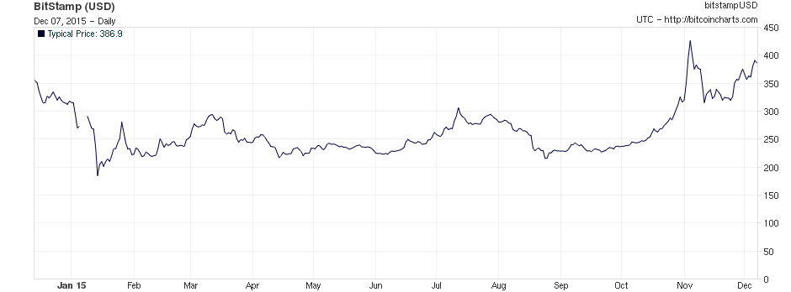

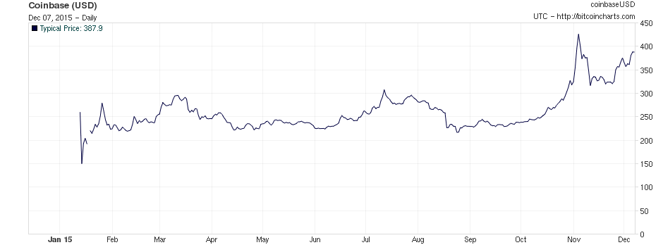

Unfortunately, Localbitcoins does not have good chart data available due to the nature of their business model (prices are shown as a per sale, rather than per bitcoin price on the chart, and therefore the chart is meaningless). As we can see from the Bitstamp and Coinbase charts, the slight premium that Coinbase charges over Bitstamp has remained very constant over time. This suggests that the differences in bitcoin prices between exchanges has not changed much over the past year, and is a less interesting topic to discuss than the reasons for why exchanges have different bitcoin prices in the first place.

**6: References**

<http://www.bitcoincharts.com/markets/>

<https://bitcointalk.org/index.php?topic=1001784.0>

<https://www.bitstamp.net/>

<https://www.coinbase.com/>

<http://www.coindesk.com/price/>

<https://localbitcoins.com/>